Task 1: System Monitoring Setup

Step 1: Install Monitoring Tools (htop or nmon)
Option A: Install htop
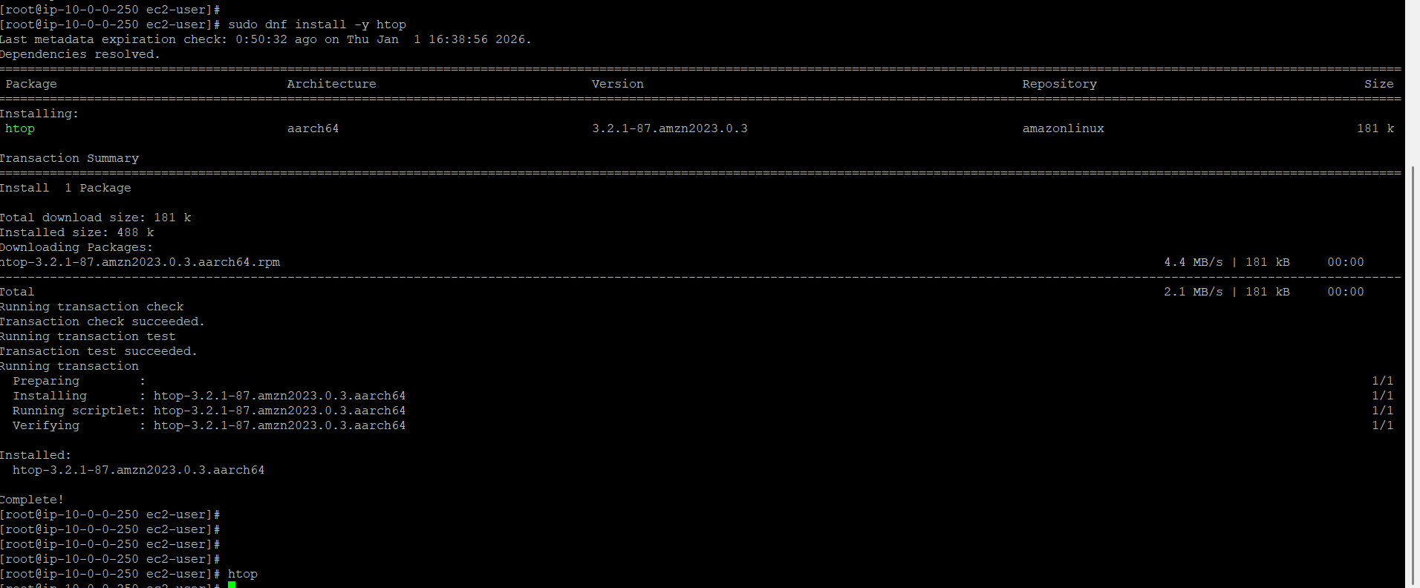

htop running showing CPU, memory, processes:
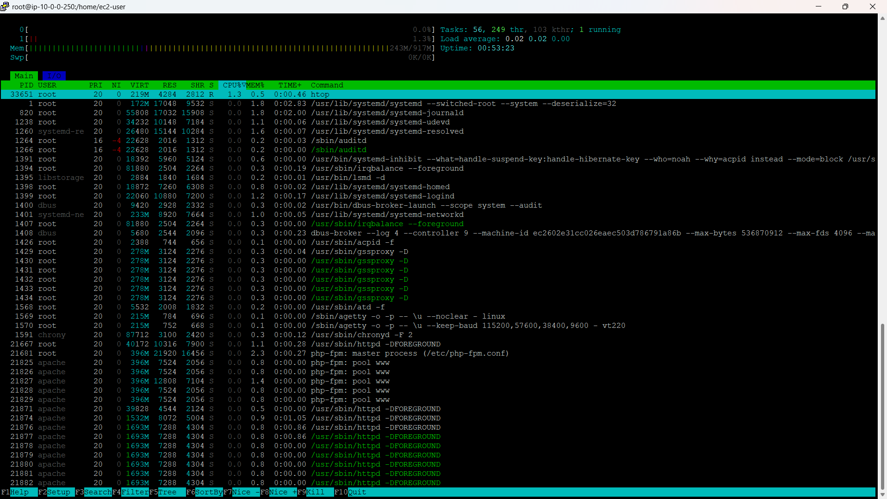

Step 2: Monitor CPU, Memory & Processes
CPU usage → shown per core at top
Process monitoring
Sort by CPU → CPU%
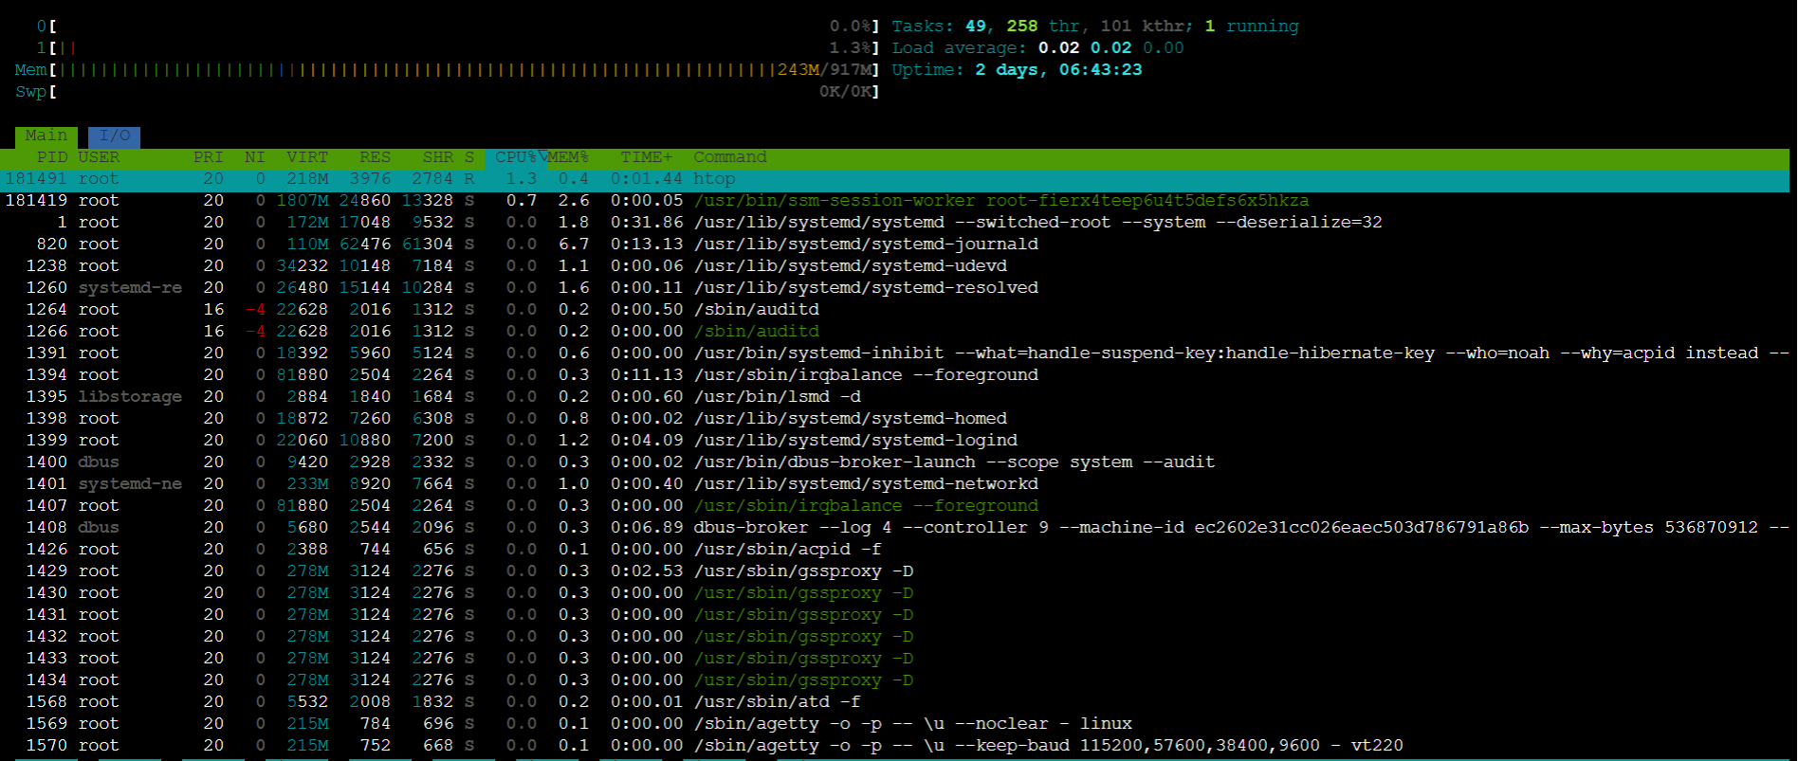

Memory usage → RAM & swap usage bars
Sort by Memory → MEM%
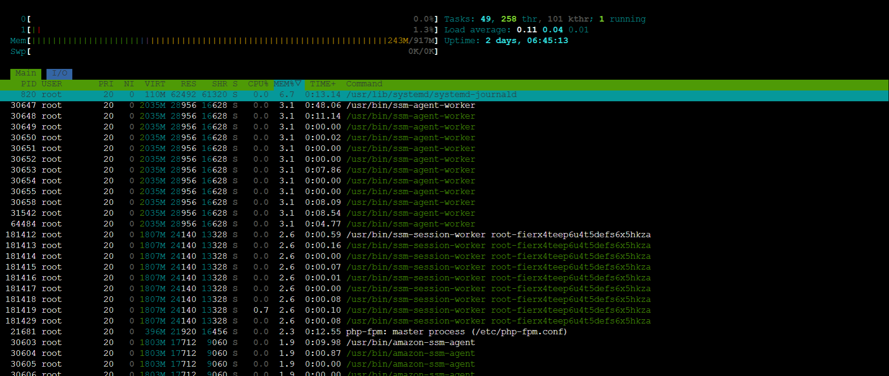

Step 3: Disk Usage Monitoring (df & du)
3.1 Check overall disk usage (filesystem level)
Explanation:
Shows total disk size, used, available, usage %
Helps track storage availability
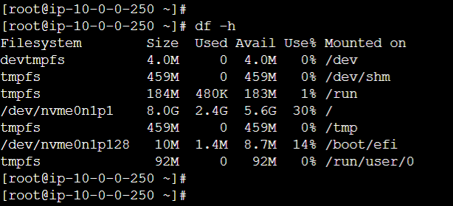

3.2 Check for root directories-level usage:
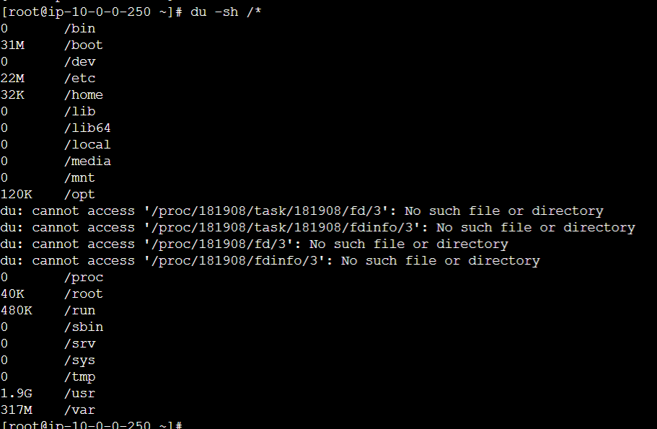

3.3 Check directory-level usage:
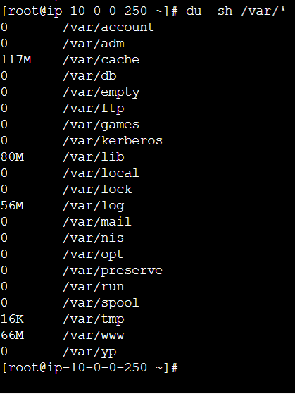

Step 4: Identify Resource-Intensive Processes
Top CPU consuming processes:
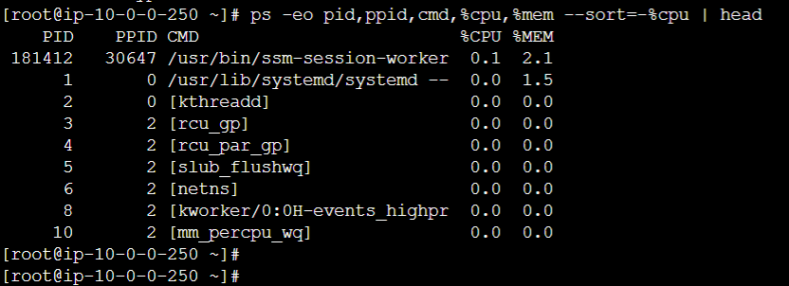

Top memory consuming processes:
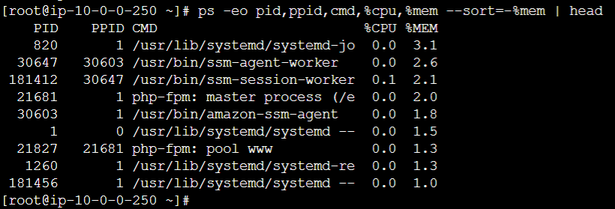

Step 5: Create Basic Reporting & Logs
5.1 Create log directory:
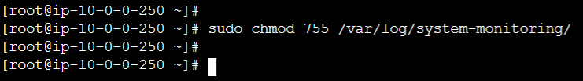
5.2 Save monitoring outputs to log files
CPU & Memory log: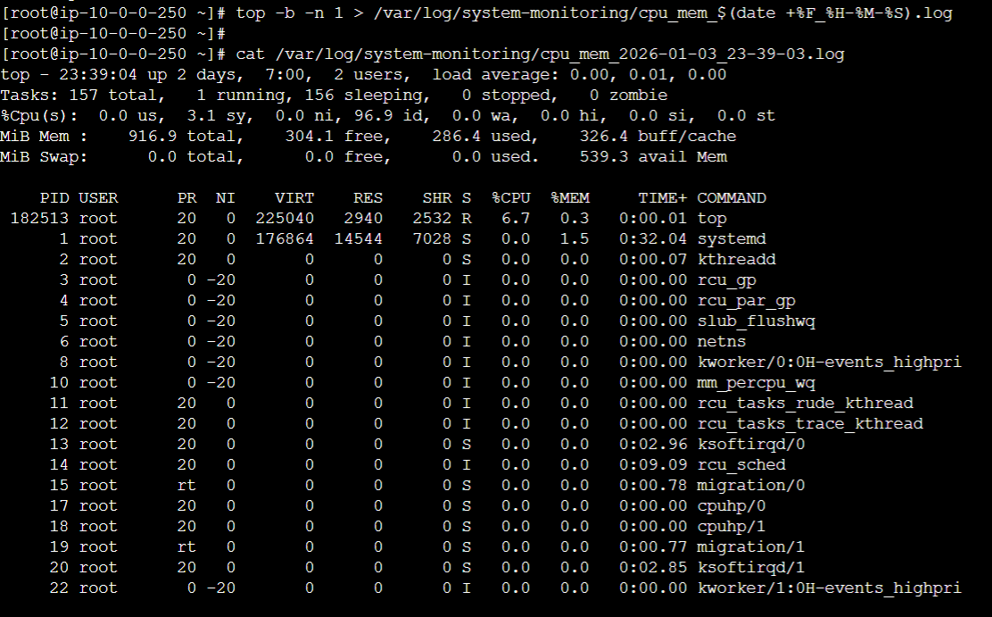

Disk usage log:
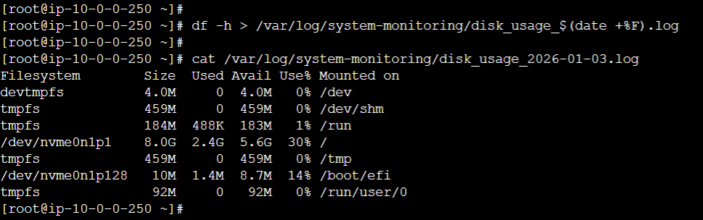
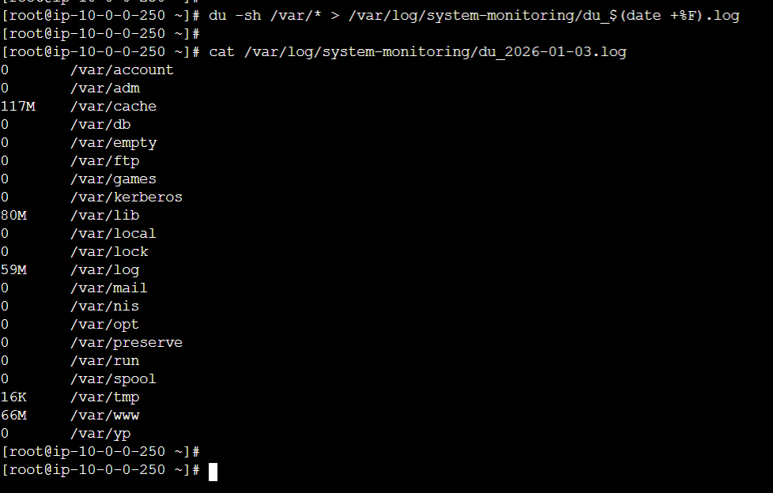

Process monitoring log:
Top Processes log:
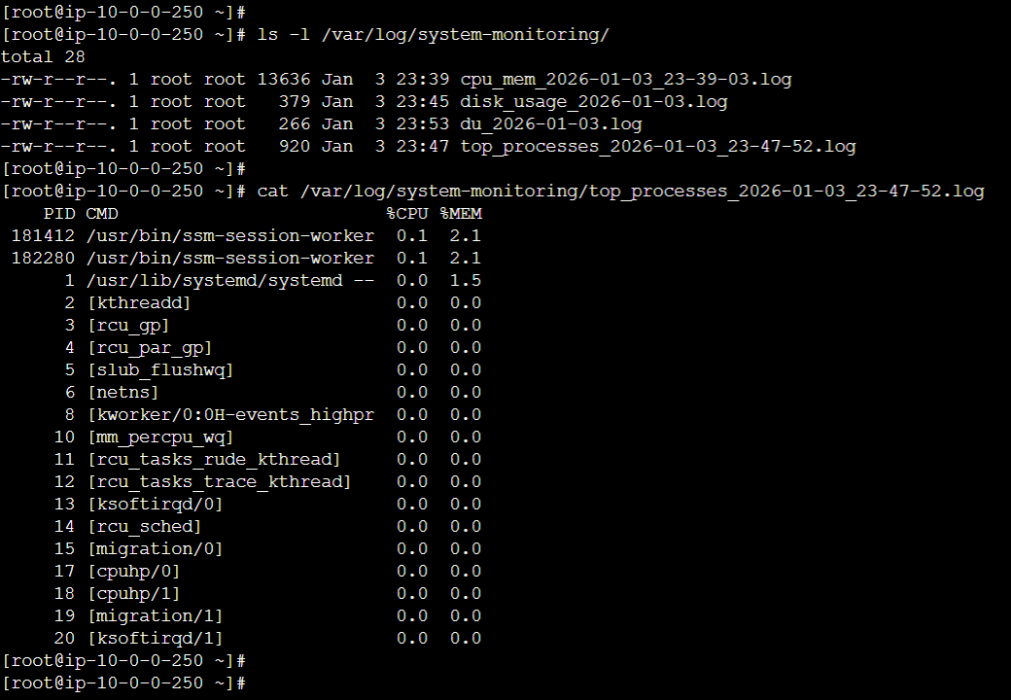
Step 6: (Optional but Recommended) Automate Logging via Cron
Crontab entry:
